SOUND
Music & Video Streaming Platform
Project Documentation
PHP • MySQL • HTML • CSS • JavaScript

Group Members
Name | ID
Muhammad Ali | 1699454
Asim Ali | 1698550
Muhammad Fahad | 1702051
Shafia Siraj | 1700031
Ayan Siddique | 1690523

1. Overview
SOUND is a PHP-based web application for streaming and managing music and videos. It provides a complete user authentication system, media playback for both music and video, playlist management, search and filtering, and a full administration panel for managing platform content.

2. Features
- User Authentication: Secure user registration, login, and logout functionality.
- Media Playback: Support for both music and video streaming.
- Music Catalog: Browse music with advanced filtering by Artist, Year, and Language.
- Playlists: Create and manage personalized playlists.
- Search Functionality: Quickly find specific tracks, videos, or artists.
- Admin Panel: A dedicated administrative dashboard for managing users, music, videos, genres, artists, and other site metadata.
- User Dashboard: A personalized space for users to manage their profile and saved content.

3. Project Structure
Path | Description
/admin/ | Administrative panel files.
/assets/ | Static assets (CSS, JS, images, etc.).
/config/ | Database and application configuration files.
/includes/ | Reusable components like headers, footers, and sidebars.
/services/ | External service integrations or background services.
/uploads/ | Directory for user-uploaded or site media files.
/user/ | User dashboard pages.
SOUND_db.sql | Database schema and initial data.
.env.example | Template for environment variables.

4. Installation & Setup

4.1 Prerequisites
A web server environment with PHP and MySQL installed — e.g. XAMPP, WAMP, or a LAMP stack.

4.2 Clone / Copy
Place the project files into your web server's root directory (e.g. htdocs for XAMPP).

4.3 Database Setup
- Create a new MySQL database named SOUND_db (or a preferred name).
- Import the provided SOUND_db.sql file into the newly created database.
- Update the database connection credentials in config/db.php if necessary.

4.4 Environment Variables
- Copy .env.example to a new file named .env.
- Add any required server-only credentials, such as the YOUTUBE_API_KEY, to the .env file.

4.5 Run the Application
Access the project through a web browser, e.g.:
http://localhost/SOUND

5. Technologies Used
- Backend: PHP
- Database: MySQL
- Frontend: HTML, CSS, JavaScript

6. Application Walkthrough (Screenshots)
The following pages walk through the SOUND platform screen by screen, covering the public-facing site as well as the admin panel.

AUTHENTICATION
Login Page
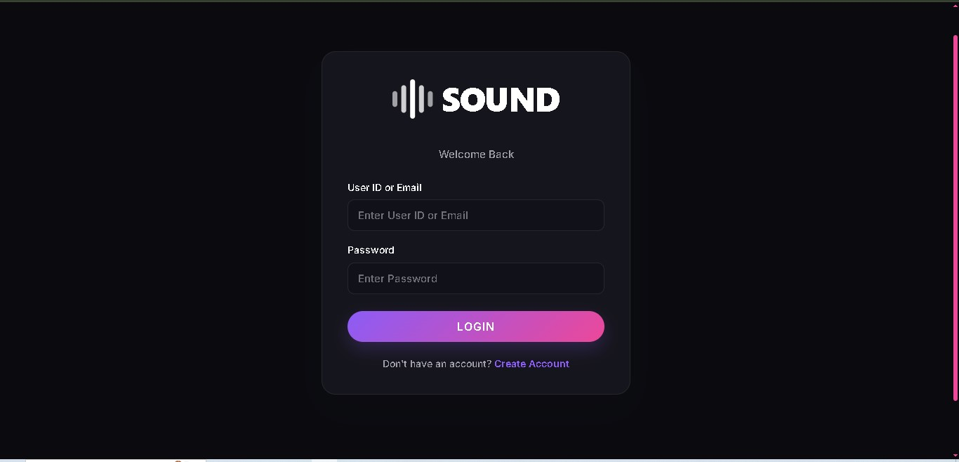
This is the entry point of the application. Registered users sign in using their User ID or Email along with their Password. The form is kept minimal for a clean user experience, and a “Create Account” link is provided below the Login button for users who do not yet have an account.

AUTHENTICATION
Create Account Page
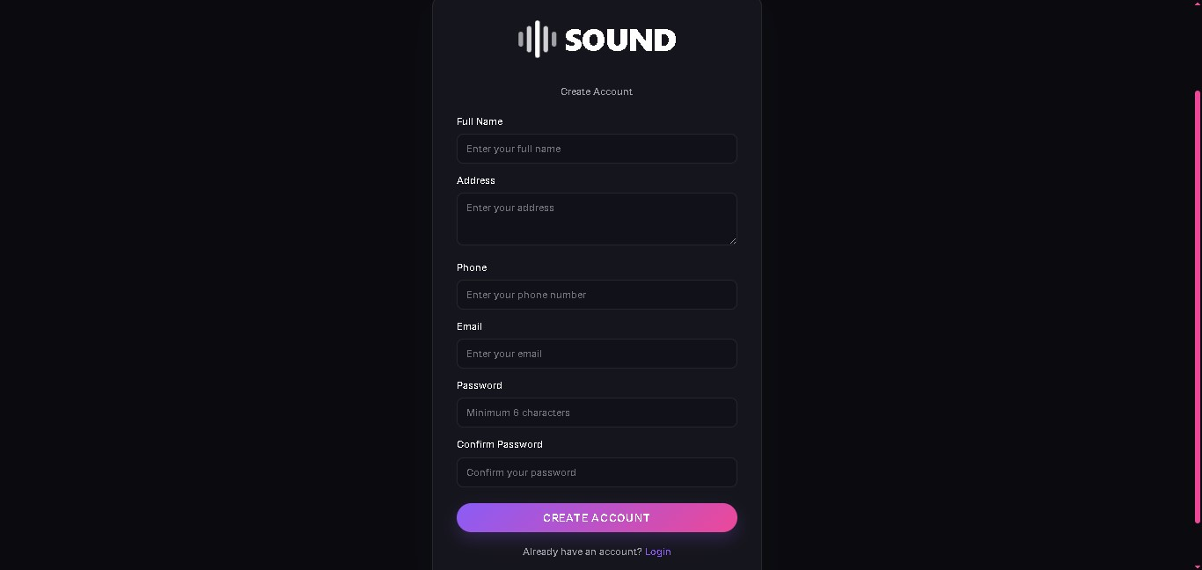
New users can register for a SOUND account from this page by providing their Full Name, Address, Phone number, Email, and a Password (with confirmation). Basic validation ensures the password meets a minimum length before the account is created. Once registered, the user is redirected to the Login page to sign in.

HOME & BROWSING
Home Page — Hero Section
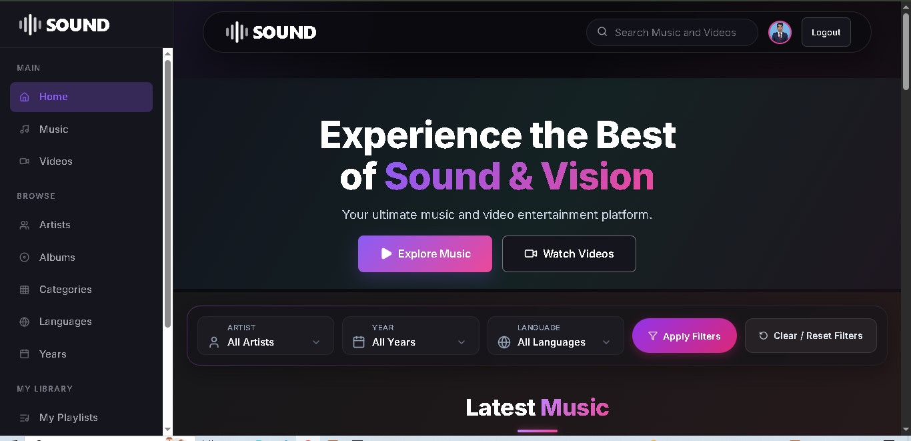
The home page welcomes users with a hero banner (“Experience the Best of Sound & Vision”) and two primary call-to-action buttons, “Explore Music” and “Watch Videos”, that take the user directly to the respective sections. Below the banner, filter controls let users narrow content by Artist, Year, and Language before applying or clearing the filters.

HOME & BROWSING
Home Page — Latest Music
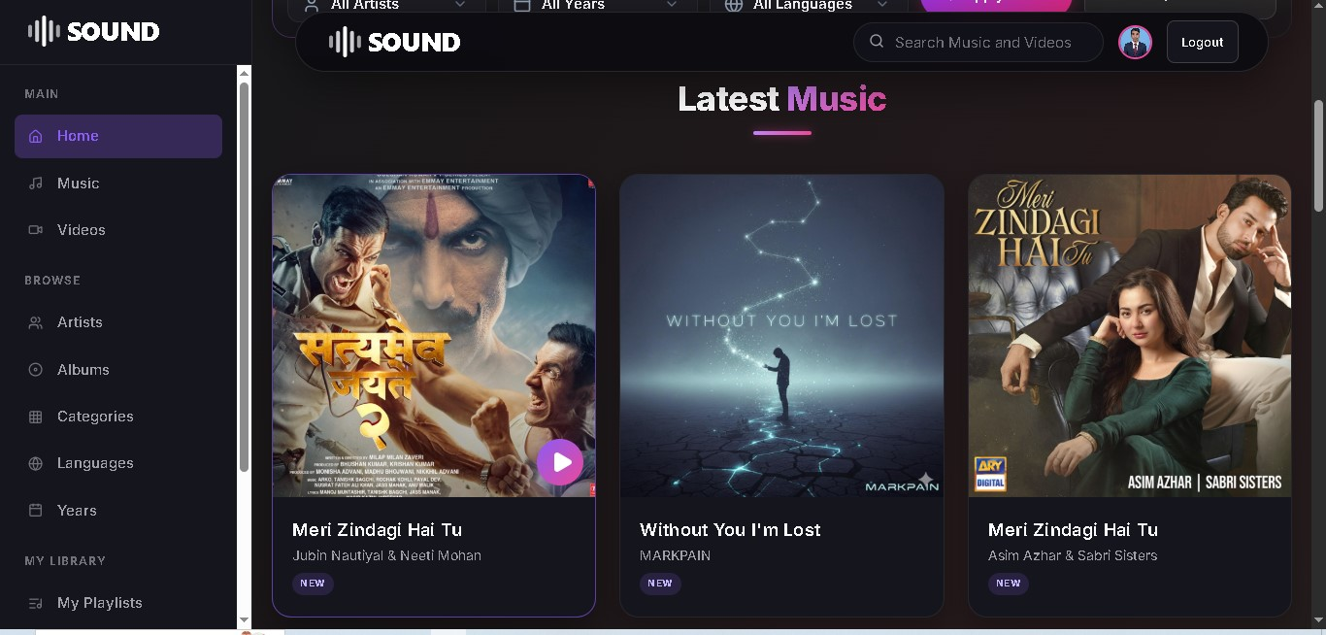
Scrolling down the home page reveals the “Latest Music” section, which displays the most recently added tracks as cards with cover art, title, artist name, and a “NEW” badge. Clicking a card takes the user to that track's detail page for playback.

MUSIC & VIDEO PLAYBACK
Music Detail Page
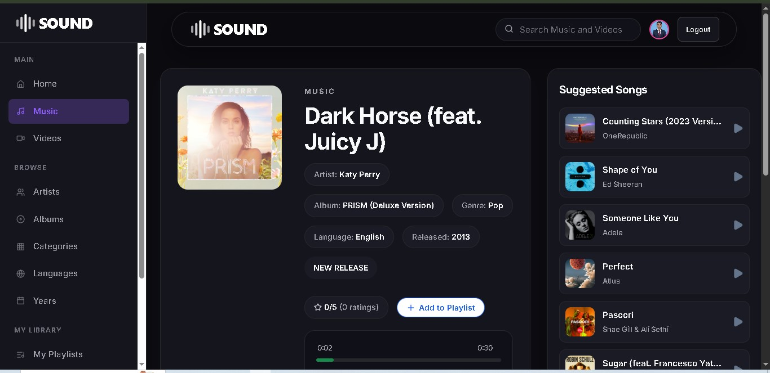
This page shows full details of a selected track, including the artist, album, genre, language, and release year, along with an embedded audio player and progress bar. Users can rate the track and add it to a playlist using the “Add to Playlist” button. A “Suggested Songs” panel on the right recommends related tracks to keep users engaged.

MUSIC & VIDEO PLAYBACK
Video Playback Page
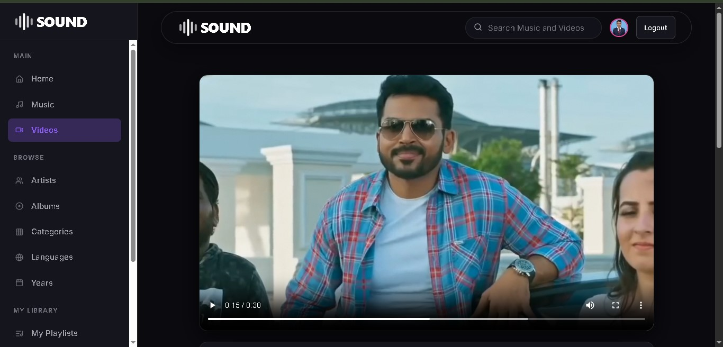
The video playback page streams the selected video using a standard HTML5 video player with play/pause, volume, fullscreen, and progress controls, allowing users to watch music videos directly within the platform.

USER DASHBOARD
User Profile Page
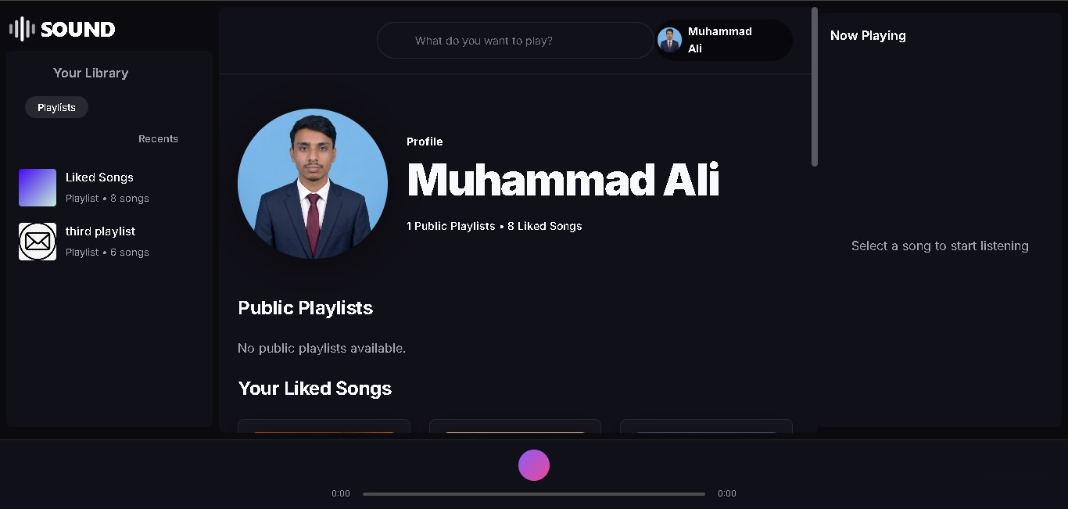
The user profile page acts as a personal dashboard, displaying the user's name, profile picture, and a summary of their activity (public playlists and liked songs). A search bar at the top (“What do you want to play?”) lets the user quickly find and play content, while the sidebar lists their playlists and a “Now Playing” panel shows the current track.

ADMIN PANEL
Admin Dashboard Overview
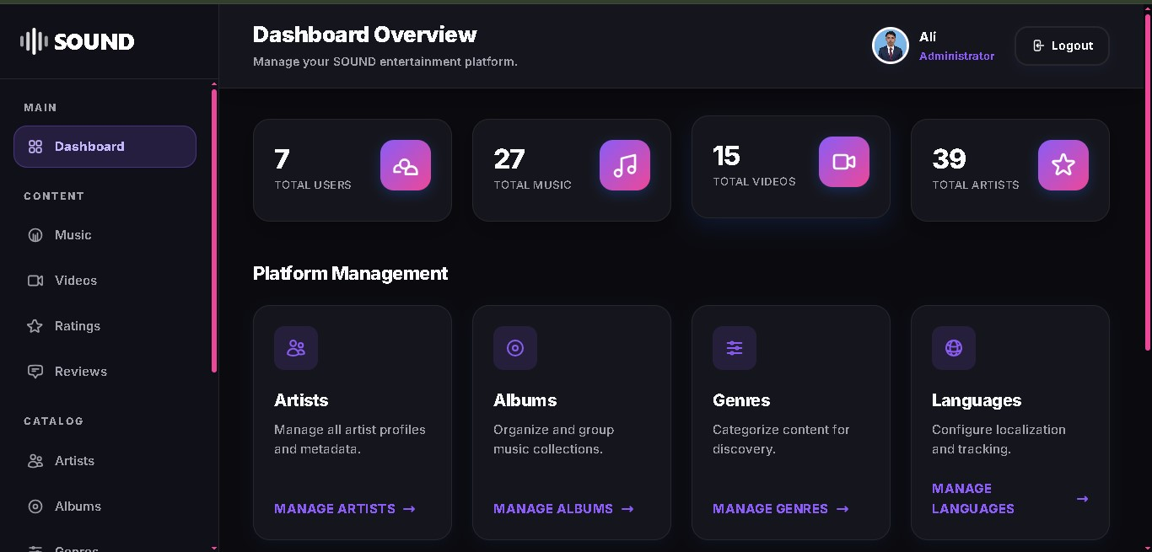
The admin dashboard gives administrators a quick snapshot of the platform, showing total counts of Users, Music, Videos, and Artists at a glance. Below the summary cards, a “Platform Management” section provides quick links to manage Artists, Albums, Genres, and Languages.

ADMIN PANEL
Admin — Music Management
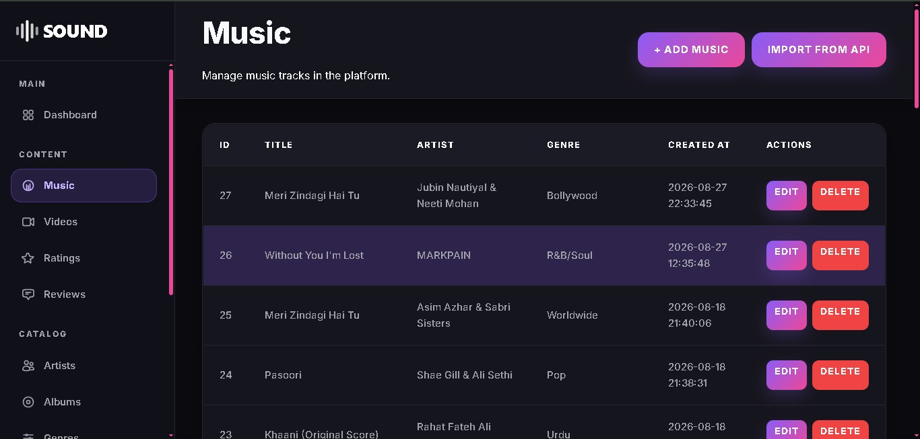
This screen lists all music tracks in the platform in a table format, showing the ID, Title, Artist, Genre, and the date each track was created. Administrators can edit or delete any track using the action buttons, and can add new tracks manually or import them directly from an external API using the buttons at the top.

ADMIN PANEL
Admin — Add Music Form
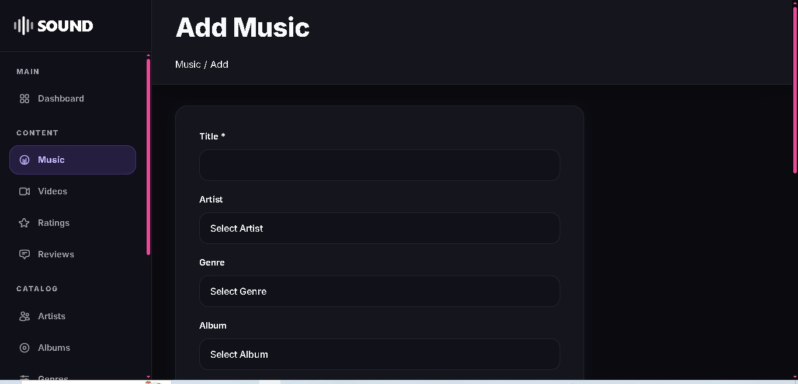
When adding a new track, the administrator fills in the Title (required), and selects the Artist, Genre, and Album from dropdown menus. This keeps the music catalog consistent by linking each track to existing artist, genre, and album records.

ADMIN PANEL
Admin — Manage Ratings
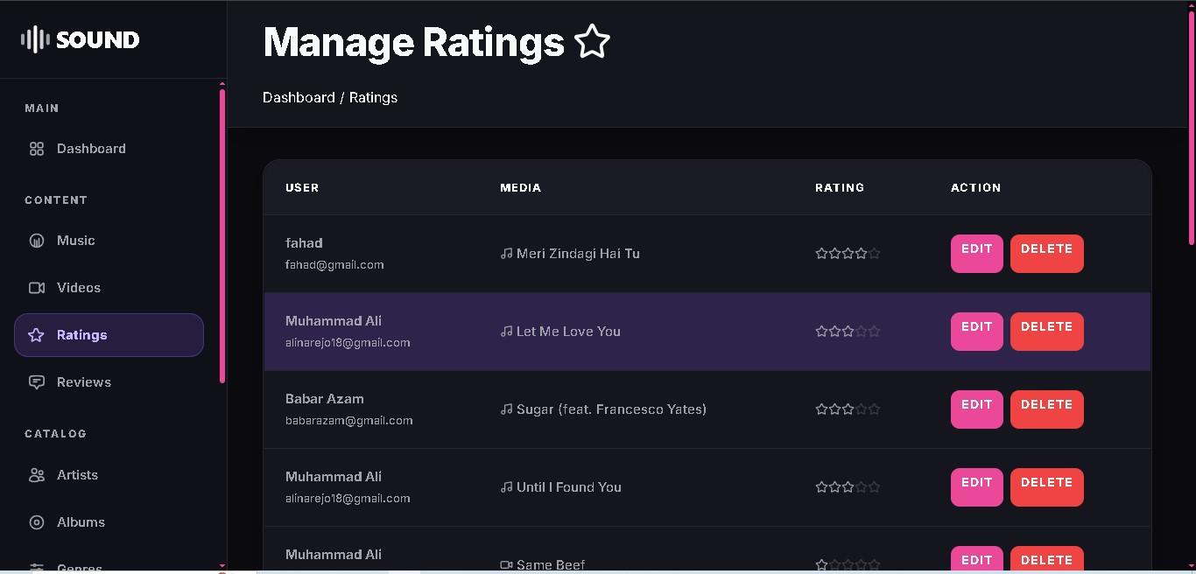
This page lets administrators view and moderate all ratings submitted by users across the platform. Each row shows the user's name and email, the media (music or video) they rated, and their star rating, with Edit and Delete actions available for moderation.

7. User Flow
The diagram below shows the typical journey a regular user takes through the SOUND platform, from signing up to playing content and managing their profile.
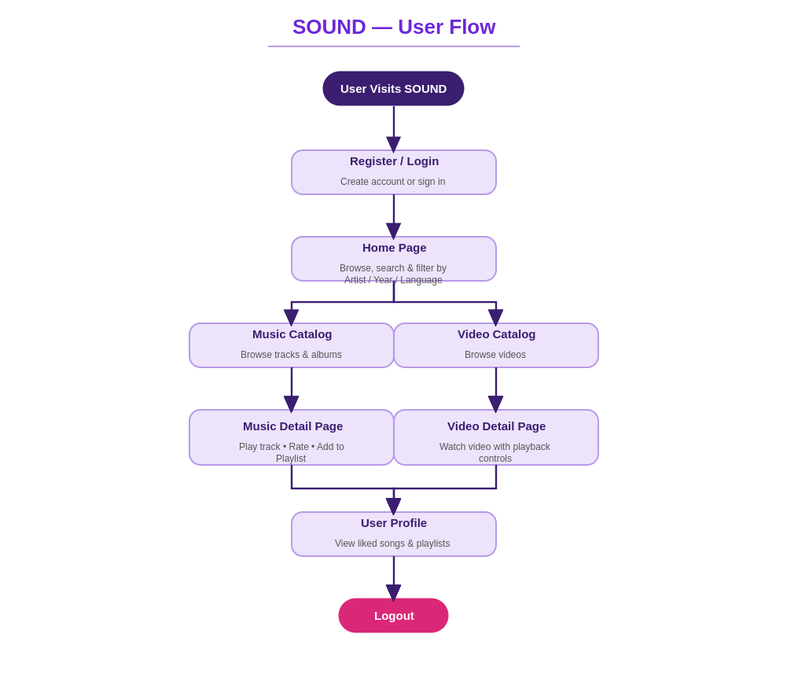

8. Admin Flow
The diagram below shows the actions available to an administrator after logging in, covering content management and moderation across the platform.
